Chief Investment Officer's Report

Karl Polen

September 6, 2016

It is a privilege to deliver this Investment Section to the Comprehensive Annual Financial Report of the Arizona State Retirement System. In this section we will discuss our investment philosophy, the investment environment and our investment results. We will also discuss our commitment to compliance, governance, rigorous measurement, and transparent reporting. Finally, we will deliver various documents and schedules providing detailed information about the ASRS investment program.

## Investment Philosophy

ASRS believes that the strategic asset allocation is the most important investment decision. Investment returns are largely, but not entirely, determined by choices made in the strategic asset allocation process. The ASRS investment team seeks to enhance returns compared strategic asset allocation benchmarks through its implementation of the investment program and tactical positioning relative to strategic targets.

Fundamentally, investment returns are rewards for risks taken. Traditional financial theory tends to regard volatility, the propensity of asset prices to go up and down, as the fundamental measure of risk. However, more recent literature takes a more nuanced view of risk considering characteristics such as valuation, liquidity, quality, momentum and market capitalization as fundamental risk factors which drive return. ASRS positions its portfolio mindful of all these risks and the risk premiums associated with them in order to structure a portfolio designed to achieve positive risk adjusted returns.

ASRS is a long term investor with a multi-decade horizon for its decisions. Additionally, the requirements to generate cash to fund payments to beneficiaries are highly forecastable and known well in advance. The current capital value of the ASRS trust is about 35 times the annual cash requirement to fund benefits. This positions ASRS ideally with a natural advantage to use this liquidity and long term perspective to patiently seek market rewards.

ASRS uses this advantage to enhance returns. For example, ASRS is a liquidity provider to the market funding less liquid assets when warranted by the risk premiums available from this type of investment. ASRS has significantly enhanced its returns and diversification through the implementation of its private markets investing program which includes investments in real estate, private equity and private debt. In another example, ASRS is a value oriented investor and we seek to capitalize on market dislocations which affect asset prices and risk premiums. Although any form of market timing is notoriously difficult, we nevertheless favor assets priced cheaply to historic norms. Our goal is to buy assets when they are cheap and then patiently wait for them to recover. In a final example, regulatory changes affecting commercial banks have forced them to exit markets which they previously dominated. This has created attractive opportunities in these markets for non-bank participants for investors willing to commit to hold periods of several years.

Our long horizon for our investments is a key advantage that allows us to tolerate short term volatility and enables us to focus on value, liquidity and other risk factors that produce superior returns but require patience to achieve results.

## Investment Environment and Results

Global capital markets have been impacted in recent years by the global financial crisis and other market dislocations. While the market produced excellent returns after the end of the last recession, those returns have been lower in the last couple years as the expansion enters a later stage with slower growth. In order to sustain growth, central banks around the world have attempted to stimulate economic activity through low policy interest rates and so-called "quantitative easing" which involves central bank purchases of assets pushing liquidity in to the markets. These measures impact asset returns and asset prices. Interest rates are at record lows with negative interest rates seen in certain European and Asian markets. In this context, asset returns have recently been below long term averages.

The following chart shows market returns for the last 15 years for the public market asset classes included in the ASRS strategic asset allocation.

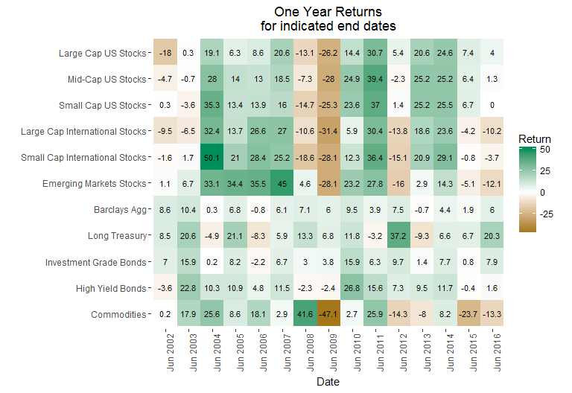

The following chart shows returns earned by ASRS over the last 40 years compared to market benchmarks. While ASRS has achieved returns higher than its actuarial return target of 8% over a span of decades, the most recent ten year period which includes the global financial crisis has yielded lower returns. ASRS has outperformed market benchmarks throughout the 40 year period. All returns presented in this report are on a total return basis, net of all fees and based on market values.

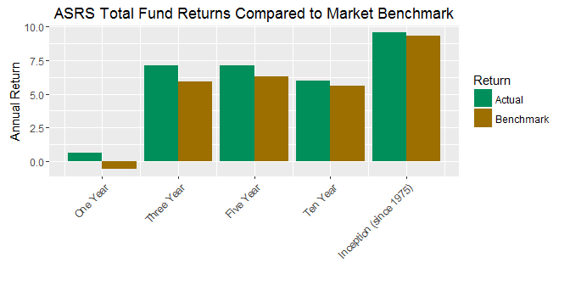  
 The following chart shows the returns realized by ASRS for the major asset classes and total fund for the one and three year periods.

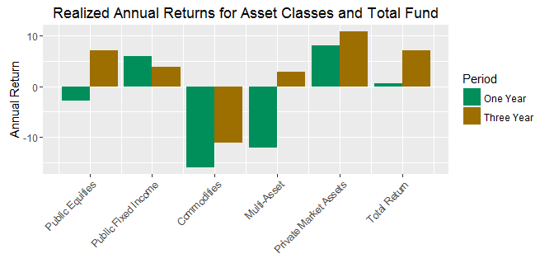

While recent market returns have been below long run averages, the ASRS investment team has been able to add value through their implementation of the investment program. In the most recent year, the benchmark market return for the ASRS portfolio was -.6%, but ASRS outperformed the total return by 1.2% yielding a total return of .6%. In the most recent three years, the market benchmark return was was 5.9% and ASRS outperformed this benchmark by 1.2% yielding a total return of 7.1%.

An investment program can outperform in two ways. First, an investor can select managers or strategies which outperform the market and any difference in performance resulting from this is called "selection" effect. Second, an investor can overweight or underweight particular assets in comparison to the prescribed weight in the strategic asset allocation and any difference in performance resulting from this is called "allocation" effect. The following chart analyzes ASRS outperformance by showing the source of the outperformance from selection effect in the major asset classes and overall allocation effect. As you can see, selection effects from private market assets were quite positive contributing much of the overall outperformance. Outperformance from public market assets was smaller, as would be expected in these more efficient markets. Allocation effects were mixed, but positive over the three year period.

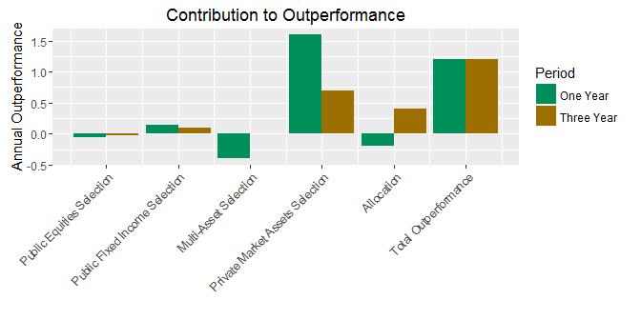  
 The investment environment of the last several years has been challenging with choppy equity markets and record low interest rates. With 50% of our assets invested in public equities ASRS returns are strongly influenced by the stock market. Our asset allocation strategies and our private market initiatives have made a positive contribution to both total return and outperformance. With 1.2% per annum outperformance over the last three years, the management efforts of the ASRS team have added over $1 billion in value to the ASRS fund.

## Governance and Compliance

ASRS operates the investment program in accordance with statutory requirements under the direction of the ASRS Board and Executive Director. ASRS has adopted a formal and well documented governance process as set forth in the Board Governance Manual and various Strategic Investment Procedures and Standard Operating Procedures which have been adopted by the board and ASRS management.

The investment program is further guided by an Investment Policy Statement which incorporates Investment Beliefs which are adopted by the ASRS Board. As noted above, the investments are implemented in accordance with a Strategic Asset Allocation which are also adopted by the board with input from investment staff and the external investment consultant. Copies of the Investment Policy Statement and Strategic Asset Allocation are included in the materials for this Investment Section.

Investments are implemented by the ASRS investment team under the direction of the Executive Director and with oversight by the external investment consultant and the board investment committee. In accordance with written policies, investment decisions are made by asset class committees which meet monthly, or more frequently if necessary, and are documented by formal minutes and meeting materials which consist of staff reports and external consultant reports. The external investment consultant attends the asset class committee meetings to remain informed on investment matters and to monitor that all governance procedures are followed.

Compliance with statutes and policies is further monitored by our custody bank which checks every trade and reports daily on the compliance status of the portfolio. Additionally, external consultants monitor the private markets program reviewing partnerships annually to confirm that fees are correctly calculated and reported, valuation policies are observed and that partnership is being administered in accordance with the terms of the partnership agreement.

## Cost

While cost management is not an investment strategy per se, cost reduction is one of the most important ways to improve investment performance. ASRS aggressively manages cost to help ensure the highest value is achieved for all our investment expenditures.

In the case of public markets where research and experience indicate that the prospects for adding value through management are limited, we are parsimonious in the payment of fees. We manage aproximately 50% of public market assets in house at effectively zero incremental cost. Any outsourced asset management occurs at competitively negotiated fees consistent with the market for investors our size.

In the case of private markets, we have implemented a program to reduce cost by concentrating our relationships with a smaller number of highly qualified managers who agree to enter in to custom negotiated partnerships at reduced fees. These partnerships, called "separate accounts", provide benefits to ASRS beyond reduced fees including custom investment criteria and favorable liquidity terms that give ASRS rights to influence or determine the pace of investment and liquidation of the partnership. ASRS has achieved substantial fee savings through the separate account program and returns from the program have exceeded market averages. ASRS plans to continue to grow the separate account program to around 75% of private market assets.

## Reporting and Performance Measurement

ASRS has implemented a comprehensive and transparent system of reports to keep the ASRS Management, Board and the public informed on ASRS investments. ASRS complies with all required reporting under GASB standards and voluntarily complies with recommended disclosures of the Government Financial Officers Association ("GFOA"). All GFOA recommended disclosures are included in this investment section.

Additionally, ASRS has been a leader in adopting rigorous investment performance measurement systems. ASRS believes that sophisticated performance measurement contributes to the efficacy of portfolio management, improves decisions and leads to better results. Starting in 2012, ASRS implemented performance measurement systems in its private markets investments based on new research recommending "public market equivalent" measurements of performance. ASRS continued the performance measurement project focusing on public equities and implementing Brinson style attribution analysis across the portfolio, returns based performance analysis using various statistical methods across rolling time frames and and holdings based style analsis across rolling time frames. ASRS plans to complete the performance measurement project in 2017 adding processes for fixed income and total fund analysis.

## Technology

ASRS is committed to using state of the art technology to bring the most sophisticated analytical methods to its decisions, to implement quality in data bases and information systems and to continuously enhance the producitivity of the investment team. As noted above, ASRS is implementing an ambitious performance measurement system project greatly increasing both the quality and quantity of information available for investment decisions. We are implementing this at essentially zero incremental cost utilizing the analytical expertise and software coding skills of existing staff. Through automation of tasks previously performed by hand we are increasing the amount of time available for higher value and more creative work. We also increase the reliability of information through automation and elimination of manual steps. We plan to continue these efforts through completion of the performance measurement system, further enhancements to reporting systems and potential enhancements of risk management systems.

## Conclusion

It is an honor to serve the members and beneficiaries as your Chief Investment Officer. We hope you find the materials in this Investment Section informative and helpful in understanding the investments of the Arizona State Retirement System.

Sincerely,

Karl Polen